Programming Assignment #1

0611031 資工10 謝至恆

**目標:**

This programming exercise concerns the move of a "knight" in a 8x8 chessboard. A knight's moves are limited to (+-1,+-2) or (+-2, +-1) from its current position. Here you need to write a program that finds the optimal (minimum number of steps) path between two given locations on the chessboard.

其實就是象棋中馬的走法，判斷要動幾步才能到達目標地點。

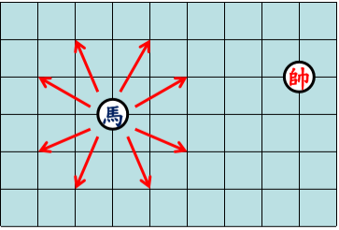

馬一共有8個方向可以走(在不超出邊界的情況下)

例子:

from A to B (0,0)到 (2,2) 最佳路徑 : (0,0)(2,1)(0,2)(1,0)(2,2)

使用上課學到的BFS DFS A* IDA* 方法來達到效果。

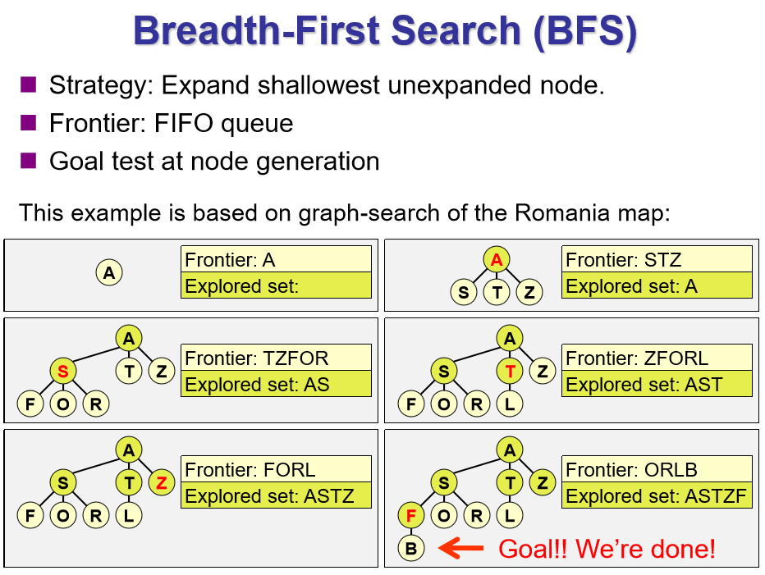

**概念 : 由淺入深 一層找完再找下一層**

因為是一層一層找，所以一定會找到一個最佳解。

使用Queue的方式來找解，一次放一層的queue把8個方向的值做檢查，如果沒有超出棋盤範圍也沒有走到過，就push進queue裡面然後把一開始的起點pop掉用while迴圈一直找直到得到一組解為止，得到的解一定是路徑最短，但不是唯一解。可以改變8個方向依序的順序就可以得到不同的解。

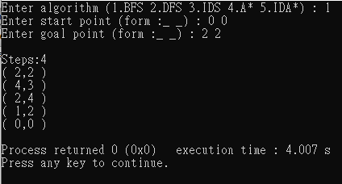

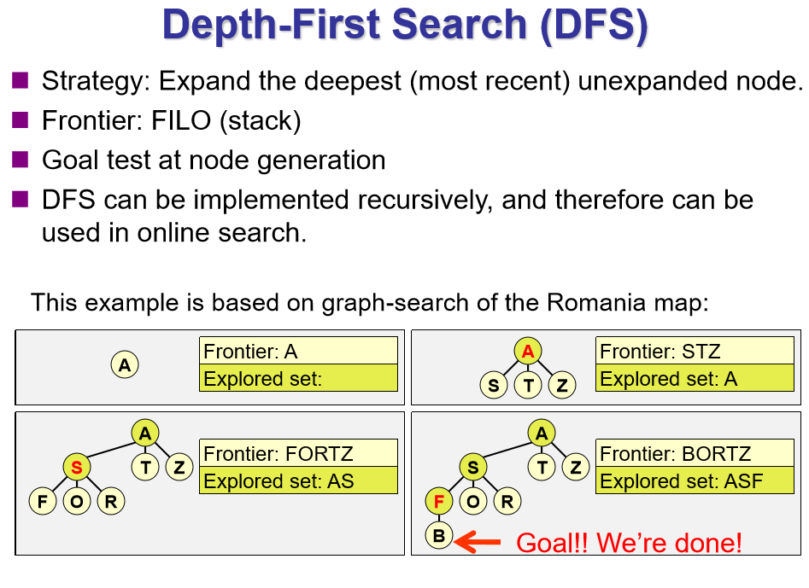

**概念 : 一條支線找到底，沒有發現解再繼續找下一條支線。**

利用BFS得到的觀念，但是函式是用遞迴的方式來找，這樣就可以一直跑到底，看看有沒有正確解答，如果找不到就會回到上一層在換8個方向中還沒試過的方向繼續找，就可以實現DFS先往下面找的方法。如果問題有解DFS找的到解，但不一定是最佳解，因為他是先往深處找，有可能其他條支線有比較淺的解答，但他不會先看。

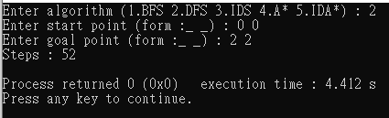

Iterative deepening search (IDS)

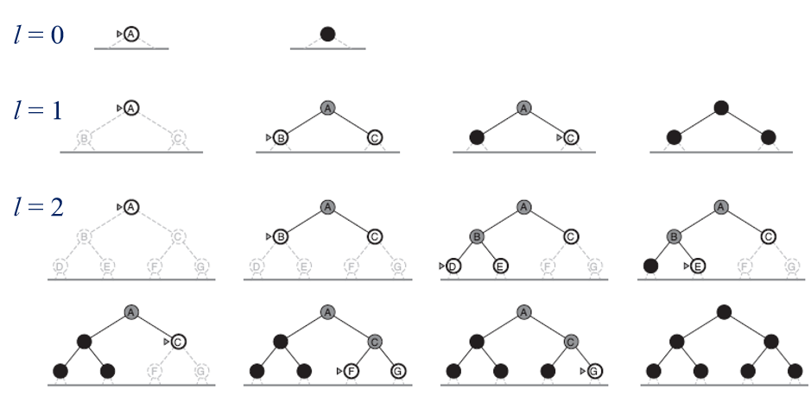

概念 : 利用一層一層的DFS概念來達到BFS的效果，可以想成受限制的DFS，每搜尋完一層後，再將深度限制加大，再繼續做下去。

逐步放寬限制深度，每次重新跑，跑到限制深度還沒找到解就放寬限制深度再重跑一次直到得解

找的方式就跟BFS大同小異。

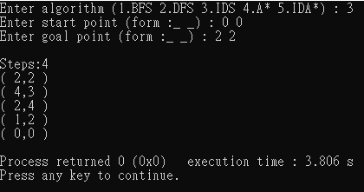

A* search

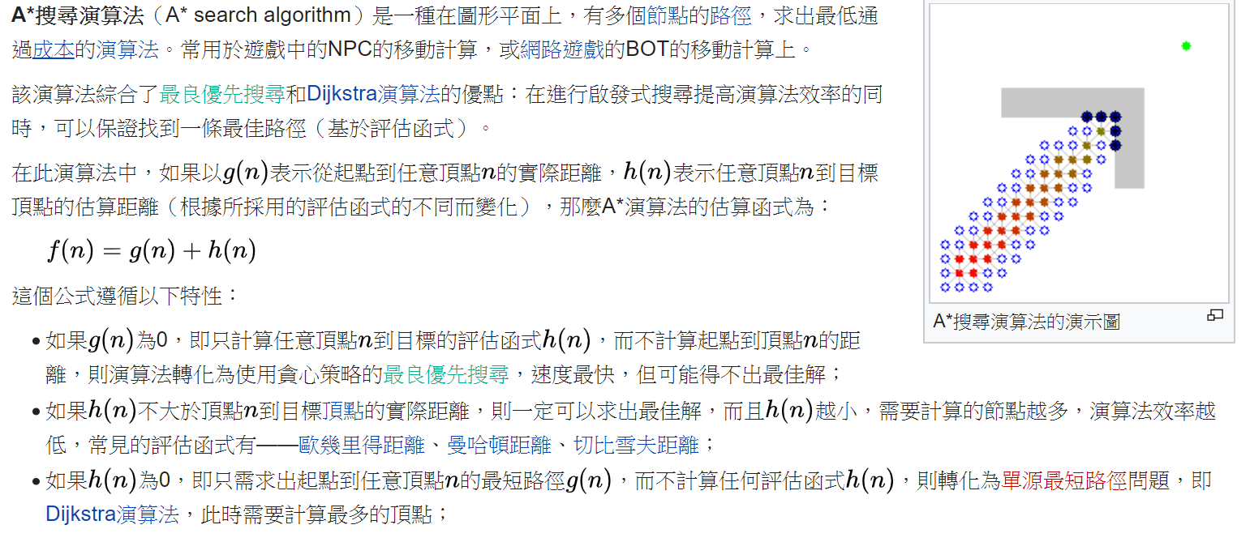

**概念 : 起始到目標的距離可以拆成 起始點到任一點的距離+此任一點到終點的距離。也就是f(n) = g(n) +h(n)**

**可以利用這個方法來簡化問題**

Heuristic function: A simple heuristic function to use is floor((|dx|+|dy|)/3), where (dx,dy) is the vector from the current location to the goal, and floor(v) is the largest integer equal to or less than v.

利用給的Heuristic function下去把8個方向的值先求出一個值，再從小到大去執行對應的方向，再利用BFS方式迴圈，有點像greedy algorithm的方式來求解，最後不一定會得到最佳解，但會比DFS接近很多。

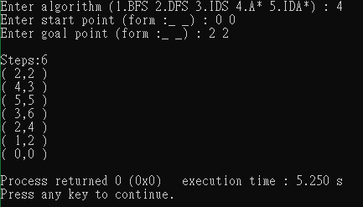

Iterative deepening A* (IDA*)

**概念 : 是對狀態空間的搜尋策略。它重複地執行一個有深度限制的**[**深度優先搜尋**](https://zh.wikipedia.org/wiki/%E6%B7%B1%E5%BA%A6%E4%BC%98%E5%85%88%E6%90%9C%E7%B4%A2)**，每次執行結束後，它增加深度并迭代，直到找到目標狀態。可以理解成疊加的A\***

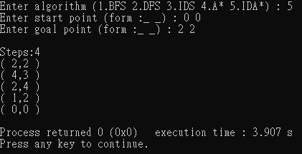

**觀察 :**

BFS可以準確得到最佳解，A*是估計一個可能能求到最佳解的值再下去找，雖然不一定是最佳但也很接近了，DFS就是一條路窮舉，如果全部展開也可以找到最佳解，但如果是先找到就停就很難找到最佳解了，如果數據很大就很沒效率。

**心得 :**

這次的作業我學到了queue這個函式，也複習很多之前的工具，讓我更了解上課的內容，以及可以用來做那些運用，各個方法的優缺點。

**問題 :**

不過我還是有點不太懂Iterative deepening的意義，感覺就是換一個想法做一樣的事，不過我感覺還是BFS最直觀也最好用

**未來的想法 :**

感覺很多問題都可以用類似的想法，做樹狀圖用這些方法來解決問題，我再想可不可以用A*來實作一個當作投資建議的參考值。

#include <iostream>

#include <iostream>

#include <queue>

#include <math.h>

#include <algorithm>

using namespace std;

//節點的結構

struct node {

int cur,x,y,step;

node *pre;

};

void BFS(int s,int s1,int g,int g1,int step){

//先做一NODE把起始點存入

node *start=new node;

start->x=s;

start->y=s1;

start->step=0;

//TABLE用來檢查下一個準備要做的點有沒有走過，走過代表有人更早就走過了，沒必要再做一次

vector<node> table;

//用來存還剩下要做的NODE

queue<node> memory;

memory.push(*start);

while(memory.front().x!=g || memory.front().y!=g1){

int x1,y1;

node *parent = new node;

*parent=memory.front();

table.push_back(memory.front());

memory.pop();

/*----------------------------方向1----------------------------*/

node *next = new node;

next->x=parent->x+1;

next->y=parent->y+2;

next->pre=parent;

next->step=parent->step+1;

int check=0;

if(next->x >8 || next->x<0 || next->y >8 || next->y <0){

check=1;

}

if(next->x >8 || next->x<0 || next->y >8 || next->y <0){

check=1;

}

for(int i=0;i<table.size();i++){

if(next->x==table[i].x && next->y==table[i].y){

check=1;

break;

}

}

if(check==0){

memory.push(*next);

}

/*----------------------------方向2----------------------------*/

next->x=parent->x+1;

next->y=parent->y-2;

next->pre=parent;

for(int i=0;i<table.size();i++){

if(next->x==table[i].x && next->y==table[i].y){

check=1;

break;

}

}

if(check==0){

memory.push(*next);

}

check=0;

if(next->x >8 || next->x<0 || next->y >8 || next->y <0){

check=1;

}

/*----------------------------方向3----------------------------*/

next->x=parent->x+2;

next->y=parent->y+1;

next->pre=parent;

for(int i=0;i<table.size();i++){

if(next->x==table[i].x && next->y==table[i].y){

check=1;

break;

}

}

if(check==0){

memory.push(*next);

}

check=0;

if(next->x >8 || next->x<0 || next->y >8 || next->y <0){

check=1;

}

/*---------------------------方向4-----------------------------*/

next->x=parent->x+2;

next->y=parent->y-1;

next->pre=parent;

for(int i=0;i<table.size();i++){

if(next->x==table[i].x && next->y==table[i].y){

check=1;

break;

}

}

if(check==0){

memory.push(*next);

}

check=0;

if(next->x >8 || next->x<0 || next->y >8 || next->y <0){

check=1;

}

/*--------------------------方向5------------------------------*/

next->x=parent->x-1;

next->y=parent->y+2;

next->pre=parent;

for(int i=0;i<table.size();i++){

if(next->x==table[i].x && next->y==table[i].y){

check=1;

break;

}

}

if(check==0){

memory.push(*next);

}

check=0;

if(next->x >8 || next->x<0 || next->y >8 || next->y <0){

check=1;

}

/*-------------------------方向6-------------------------------*/

next->x=parent->x-1;

next->y=parent->y-2;

next->pre=parent;

for(int i=0;i<table.size();i++){

if(next->x==table[i].x && next->y==table[i].y){

check=1;

break;

}

}

if(check==0){

memory.push(*next);

}

check=0;

if(next->x >8 || next->x<0 || next->y >8 || next->y <0){

check=1;

}

/*-------------------------方向7-------------------------------*/

next->x=parent->x-2;

next->y=parent->y+1;

next->pre=parent;

for(int i=0;i<table.size();i++){

if(next->x==table[i].x && next->y==table[i].y){

check=1;

break;

}

}

if(check==0){

memory.push(*next);

}

check=0;

if(next->x >8 || next->x<0 || next->y >8 || next->y <0){

check=1;

}

/*------------------------方向8--------------------------------*/

next->x=parent->x-2;

next->y=parent->y-1;

next->pre=parent;

check=0;

if(next->x >8 || next->x<0 || next->y >8 || next->y <0){

check=1;

}

for(int i=0;i<table.size();i++){

if(next->x==table[i].x && next->y==table[i].y){

check=1;

break;

}

}

if(check==0){

memory.push(*next);

}

}

node result;

result=memory.front();

cout <<endl<<"Steps:"<< memory.front().step << endl;

while(result.pre){

cout << "( " << result.x << "," << result.y<<" )"<<endl;

result=*result.pre;

}

cout << "( " << result.x << "," << result.y<<" )"<<endl;

}

int ans=0;

vector<node> path;

int DFS(int s,int s1,int g,int g1,int step){

if(ans==1){

return 0;

}

node *start=new node;

start->x=s;

start->y=s1;

start->step=step;

path.push_back(*start);

node *next =new node;

next->x=start->x+1;

next->y=start->y+2;

next->pre=start;

next->step=step+1;

//下面的if 判斷有沒有解和超出邊界，else if判斷是不是到了 else 進入下一層

if(next->x >8 || next->x<0 || next->y >8 || next->y <0 || ans==1){

}

else if(next->x==g && next->y==g1){

ans=1;

cout << "Steps : "<<next->step <<endl;

}

else{

int check=0;

for(int i=0;i<path.size();i++){

if(next->x==path[i].x && next->y==path[i].y){

check=1;

break;

}

}

if(check==0){

DFS(next->x,next->y,g,g1,next->step);

}

}

next->x=start->x+1;

next->y=start->y-2;

next->pre=start;

next->step=step+1;

if(next->x >8 || next->x<0 || next->y >8 || next->y <0 || ans==1){

}

else if(next->x==g && next->y==g1){

ans=1;

cout << "Steps : "<<next->step <<endl;

}

else{

int check=0;

//cout << 2 <<endl;

for(int i=0;i<path.size();i++){

if(next->x==path[i].x && next->y==path[i].y){

check=1;

break;

}

}

if(check==0){

DFS(next->x,next->y,g,g1,next->step);

}

}

next->x=start->x+2;

next->y=start->y+1;

next->pre=start;

next->step=step+1;

if(next->x >8 || next->x<0 || next->y >8 || next->y <0 || ans==1){

}

else if(next->x==g && next->y==g1){

ans=1;

cout << "Steps : "<<next->step <<endl;

}

else{

int check=0;

//cout << 3 <<endl;

for(int i=0;i<path.size();i++){

if(next->x==path[i].x && next->y==path[i].y){

check=1;

break;

}

}

if(check==0){

DFS(next->x,next->y,g,g1,next->step);

}

}

next->x=start->x+2;

next->y=start->y-1;

next->pre=start;

next->step=step+1;

if(next->x >8 || next->x<0 || next->y >8 || next->y <0 || ans==1){

}

else if(next->x==g && next->y==g1){

ans=1;

cout << "Steps : "<<next->step <<endl;

}

else{

int check=0;

//cout << 4 <<endl;

for(int i=0;i<path.size();i++){

if(next->x==path[i].x && next->y==path[i].y){

check=1;

break;

}

}

if(check==0){

DFS(next->x,next->y,g,g1,next->step);

}

}

next->x=start->x-1;

next->y=start->y+2;

next->pre=start;

next->step=step+1;

if(next->x >8 || next->x<0 || next->y >8 || next->y <0 || ans==1){

}

else if(next->x==g && next->y==g1){

ans=1;

cout << "Steps : "<<next->step <<endl;

}

else{

int check=0;

//cout << 5 <<endl;

for(int i=0;i<path.size();i++){

if(next->x==path[i].x && next->y==path[i].y){

check=1;

break;

}

}

if(check==0){

DFS(next->x,next->y,g,g1,next->step);

}

}

next->x=start->x-1;

next->y=start->y-2;

next->pre=start;

next->step=step+1;

if(next->x >8 || next->x<0 || next->y >8 || next->y <0 || ans==1){

}

else if(next->x==g && next->y==g1){

ans=1;

cout << "Steps : "<<next->step <<endl;

}

else{

int check=0;

//cout << 6 <<endl;

for(int i=0;i<path.size();i++){

if(next->x==path[i].x && next->y==path[i].y){

check=1;

break;

}

}

if(check==0){

DFS(next->x,next->y,g,g1,next->step);

}

}

next->x=start->x-2;

next->y=start->y+1;

next->pre=start;

next->step=step+1;

if(next->x >8 || next->x<0 || next->y >8 || next->y <0 || ans==1){

}

else if(next->x==g && next->y==g1){

ans=1;

cout << "Steps : "<<next->step <<endl;

}

else{

int check=0;

//cout << 7 <<endl;

for(int i=0;i<path.size();i++){

if(next->x==path[i].x && next->y==path[i].y){

check=1;

break;

}

}

if(check==0){

DFS(next->x,next->y,g,g1,next->step);

}

}

next->x=start->x-2;

next->y=start->y-2;

next->pre=start;

next->step=step+1;

if(next->x >8 || next->x<0 || next->y >8 || next->y <0 || ans==1){

}

else if(next->x==g && next->y==g1){

ans=1;

cout << "Steps : "<<next->step <<endl;

}

else{

int check=0;

//cout << 8 <<endl;

for(int i=0;i<path.size();i++){

if(next->x==path[i].x && next->y==path[i].y){

check=1;

break;

}

}

if(check==0){

DFS(next->x,next->y,g,g1,next->step);

}

}

return 0;

}

int IDS_ans=0;

vector<node> IDS_path;

int IDS(int s,int s1,int g,int g1,int step,int level){

node *start=new node;

start->x=s;

start->y=s1;

start->step=0;

vector<node> table;

queue<node> memory;

memory.push(*start);

while(memory.front().x!=g || memory.front().y!=g1){

int x1,y1;

node *parent = new node;

*parent=memory.front();

table.push_back(memory.front());

memory.pop();

node *next = new node;

next->x=parent->x+1;

next->y=parent->y+2;

next->pre=parent;

next->step=parent->step+1;

int check=0;

if(next->x >8 || next->x<0 || next->y >8 || next->y <0){

check=1;

}

if(next->x >8 || next->x<0 || next->y >8 || next->y <0){

check=1;

}

for(int i=0;i<table.size();i++){

if(next->x==table[i].x && next->y==table[i].y){

check=1;

break;

}

}

if(check==0){

memory.push(*next);

}

next->x=parent->x+1;

next->y=parent->y-2;

next->pre=parent;

for(int i=0;i<table.size();i++){

if(next->x==table[i].x && next->y==table[i].y){

check=1;

break;

}

}

if(check==0){

memory.push(*next);

}

check=0;

if(next->x >8 || next->x<0 || next->y >8 || next->y <0){

check=1;

}

next->x=parent->x+2;

next->y=parent->y+1;

next->pre=parent;

for(int i=0;i<table.size();i++){

if(next->x==table[i].x && next->y==table[i].y){

check=1;

break;

}

}

if(check==0){

memory.push(*next);

}

check=0;

if(next->x >8 || next->x<0 || next->y >8 || next->y <0){

check=1;

}

next->x=parent->x+2;

next->y=parent->y-1;

next->pre=parent;

for(int i=0;i<table.size();i++){

if(next->x==table[i].x && next->y==table[i].y){

check=1;

break;

}

}

if(check==0){

memory.push(*next);

}

check=0;

if(next->x >8 || next->x<0 || next->y >8 || next->y <0){

check=1;

}

next->x=parent->x-1;

next->y=parent->y+2;

next->pre=parent;

for(int i=0;i<table.size();i++){

if(next->x==table[i].x && next->y==table[i].y){

check=1;

break;

}

}

if(check==0){

memory.push(*next);

}

check=0;

if(next->x >8 || next->x<0 || next->y >8 || next->y <0){

check=1;

}

next->x=parent->x-1;

next->y=parent->y-2;

next->pre=parent;

for(int i=0;i<table.size();i++){

if(next->x==table[i].x && next->y==table[i].y){

check=1;

break;

}

}

if(check==0){

memory.push(*next);

}

check=0;

if(next->x >8 || next->x<0 || next->y >8 || next->y <0){

check=1;

}

next->x=parent->x-2;

next->y=parent->y+1;

next->pre=parent;

for(int i=0;i<table.size();i++){

if(next->x==table[i].x && next->y==table[i].y){

check=1;

break;

}

}

if(check==0){

memory.push(*next);

}

check=0;

if(next->x >8 || next->x<0 || next->y >8 || next->y <0){

check=1;

}

next->x=parent->x-2;

next->y=parent->y-1;

next->pre=parent;

check=0;

if(next->x >8 || next->x<0 || next->y >8 || next->y <0){

check=1;

}

for(int i=0;i<table.size();i++){

if(next->x==table[i].x && next->y==table[i].y){

check=1;

break;

}

}

if(check==0){

memory.push(*next);

}

}

node result;

result=memory.front();

cout <<endl<<"Steps:"<< memory.front().step << endl;

while(result.pre){

cout << "( " << result.x << "," << result.y<<" )"<<endl;

result=*result.pre;

}

cout << "( " << result.x << "," << result.y<<" )"<<endl;

}

int A(int s,int s1,int g,int g1,int step){

node *start=new node;

start->x=s;

start->y=s1;

start->step=0;

vector<node> table;

queue<node> memory;

memory.push(*start);

while(memory.front().x!=g || memory.front().y!=g1){

node *parent = new node;

*parent=memory.front();

table.push_back(memory.front());

memory.pop();

int x1[8],y1[8];

float heuristic_number[8];

x1[0]=memory.front().x+1;

x1[1]=memory.front().x+1;

x1[2]=memory.front().x+2;

x1[3]=memory.front().x+2;

x1[4]=memory.front().x-1;

x1[5]=memory.front().x-1;

x1[6]=memory.front().x-2;

x1[7]=memory.front().x-2;

y1[0]=memory.front().y+2;

y1[1]=memory.front().y-2;

y1[2]=memory.front().y+1;

y1[3]=memory.front().y-1;

y1[4]=memory.front().y+2;

y1[5]=memory.front().y-2;

y1[6]=memory.front().y+1;

y1[7]=memory.front().y-1;

for(int i=0;i<8;i++){

heuristic_number[i]=(abs(g-x1[i])+abs(g1-y1[i]))/3;

}

sort(heuristic_number,heuristic_number+8);

node *next = new node;

for(int i=0;i<8;i++){

if((abs(g-x1[0])+abs(g1-y1[0]))/3==heuristic_number[i]){

next->x=parent->x+1;

next->y=parent->y+2;

next->pre=parent;

next->step=parent->step+1;

int check=0;

if(next->x >8 || next->x<0 || next->y >8 || next->y <0){

check=1;

}

for(int i=0;i<table.size();i++){

if(next->x==table[i].x && next->y==table[i].y){

check=1;

break;

}

}

if(check==0){

memory.push(*next);

}

}

else if((abs(g-x1[1])+abs(g1-y1[1]))/3==heuristic_number[i]){

next->x=parent->x+1;

next->y=parent->y-2;

next->pre=parent;

next->step=parent->step+1;

int check=0;

if(next->x >8 || next->x<0 || next->y >8 || next->y <0){

check=1;

}

for(int i=0;i<table.size();i++){

if(next->x==table[i].x && next->y==table[i].y){

check=1;

break;

}

}

if(check==0){

memory.push(*next);

}

}

else if((abs(g-x1[2])+abs(g1-y1[2]))/3==heuristic_number[i]){

next->x=parent->x+2;

next->y=parent->y+1;

next->pre=parent;

next->step=parent->step+1;

int check=0;

if(next->x >8 || next->x<0 || next->y >8 || next->y <0){

check=1;

}

for(int i=0;i<table.size();i++){

if(next->x==table[i].x && next->y==table[i].y){

check=1;

break;

}

}

if(check==0){

memory.push(*next);

}

}

else if((abs(g-x1[3])+abs(g1-y1[3]))/3==heuristic_number[i]){

next->x=parent->x+2;

next->y=parent->y-1;

next->pre=parent;

next->step=parent->step+1;

int check=0;

if(next->x >8 || next->x<0 || next->y >8 || next->y <0){

check=1;

}

for(int i=0;i<table.size();i++){

if(next->x==table[i].x && next->y==table[i].y){

check=1;

break;

}

}

if(check==0){

memory.push(*next);

}

}

else if((abs(g-x1[4])+abs(g1-y1[4]))/3==heuristic_number[i]){

next->x=parent->x-1;

next->y=parent->y+2;

next->pre=parent;

next->step=parent->step+1;

int check=0;

if(next->x >8 || next->x<0 || next->y >8 || next->y <0){

check=1;

}

for(int i=0;i<table.size();i++){

if(next->x==table[i].x && next->y==table[i].y){

check=1;

break;

}

}

if(check==0){

memory.push(*next);

}

}

else if((abs(g-x1[5])+abs(g1-y1[5]))/3==heuristic_number[i]){

next->x=parent->x-1;

next->y=parent->y-2;

next->pre=parent;

next->step=parent->step+1;

int check=0;

if(next->x >8 || next->x<0 || next->y >8 || next->y <0){

check=1;

}

for(int i=0;i<table.size();i++){

if(next->x==table[i].x && next->y==table[i].y){

check=1;

break;

}

}

if(check==0){

memory.push(*next);

}

}

else if((abs(g-x1[6])+abs(g1-y1[6]))/3==heuristic_number[i]){

next->x=parent->x-2;

next->y=parent->y+1;

next->pre=parent;

next->step=parent->step+1;

int check=0;

if(next->x >8 || next->x<0 || next->y >8 || next->y <0){

check=1;

}

for(int i=0;i<table.size();i++){

if(next->x==table[i].x && next->y==table[i].y){

check=1;

break;

}

}

if(check==0){

memory.push(*next);

}

}

else if((abs(g-x1[7])+abs(g1-y1[7]))/3==heuristic_number[i]){

next->x=parent->x-2;

next->y=parent->y-1;

next->pre=parent;

next->step=parent->step+1;

int check=0;

if(next->x >8 || next->x<0 || next->y >8 || next->y <0){

check=1;

}

for(int i=0;i<table.size();i++){

if(next->x==table[i].x && next->y==table[i].y){

check=1;

break;

}

}

if(check==0){

memory.push(*next);

}

}

}

}

node result;

result=memory.front();

cout <<endl<<"Steps:"<< memory.front().step << endl;

while(result.pre){

cout << "( " << result.x << "," << result.y<<" )"<<endl;

result=*result.pre;

}

cout << "( " << result.x << "," << result.y<<" )"<<endl;

}

int solution=0;

int IDA(int s,int s1,int g,int g1,int step,int level){

node *start=new node;

start->x=s;

start->y=s1;

start->step=0;

cout << "level : "<<level <<endl;

vector<node> table;

cout << "times"<<endl;

queue<node> memory;

memory.push(*start);

while(memory.front().x!=g || memory.front().y!=g1){

if(memory.front().step>level){

memory.pop();

}

node *parent = new node;

*parent=memory.front();

table.push_back(memory.front());

memory.pop();

cout << "run" <<endl;

int increase=0;

int x1[8],y1[8];

float heuristic_number[8];

x1[0]=memory.front().x+1;

x1[1]=memory.front().x+1;

x1[2]=memory.front().x+2;

x1[3]=memory.front().x+2;

x1[4]=memory.front().x-1;

x1[5]=memory.front().x-1;

x1[6]=memory.front().x-2;

x1[7]=memory.front().x-2;

y1[0]=memory.front().y+2;

y1[1]=memory.front().y-2;

y1[2]=memory.front().y+1;

y1[3]=memory.front().y-1;

y1[4]=memory.front().y+2;

y1[5]=memory.front().y-2;

y1[6]=memory.front().y+1;

y1[7]=memory.front().y-1;

for(int i=0;i<8;i++){

heuristic_number[i]=(abs(g-x1[i])+abs(g1-y1[i]))/3;

}

sort(heuristic_number,heuristic_number+8);

node *next = new node;

for(int i=0;i<8;i++){

if((abs(g-x1[0])+abs(g1-y1[0]))/3==heuristic_number[i]){

next->x=parent->x+1;

next->y=parent->y+2;

next->pre=parent;

next->step=parent->step+1;

int check=0;

if(next->x >8 || next->x<0 || next->y >8 || next->y <0){

check=1;

}

for(int i=0;i<table.size();i++){

if(next->x==table[i].x && next->y==table[i].y){

check=1;

break;

}

}

if(check==0&&next->step<=level){

memory.push(*next);

increase++;

}

}

else if((abs(g-x1[1])+abs(g1-y1[1]))/3==heuristic_number[i]){

next->x=parent->x+1;

next->y=parent->y-2;

next->pre=parent;

next->step=parent->step+1;

int check=0;

if(next->x >8 || next->x<0 || next->y >8 || next->y <0){

check=1;

}

for(int i=0;i<table.size();i++){

if(next->x==table[i].x && next->y==table[i].y){

check=1;

break;

}

}

if(check==0&&next->step<=level){

memory.push(*next);

increase++;

}

}

else if((abs(g-x1[2])+abs(g1-y1[2]))/3==heuristic_number[i]){

next->x=parent->x+2;

next->y=parent->y+1;

next->pre=parent;

next->step=parent->step+1;

int check=0;

if(next->x >8 || next->x<0 || next->y >8 || next->y <0){

check=1;

}

for(int i=0;i<table.size();i++){

if(next->x==table[i].x && next->y==table[i].y){

check=1;

break;

}

}

if(check==0&&next->step<=level){

increase++;

memory.push(*next);

}

}

else if((abs(g-x1[3])+abs(g1-y1[3]))/3==heuristic_number[i]){

next->x=parent->x+2;

next->y=parent->y-1;

next->pre=parent;

next->step=parent->step+1;

int check=0;

if(next->x >8 || next->x<0 || next->y >8 || next->y <0){

check=1;

}

for(int i=0;i<table.size();i++){

if(next->x==table[i].x && next->y==table[i].y){

check=1;

break;

}

}

if(check==0&&next->step<=level){

increase++;

memory.push(*next);

}

}

else if((abs(g-x1[4])+abs(g1-y1[4]))/3==heuristic_number[i]){

next->x=parent->x-1;

next->y=parent->y+2;

next->pre=parent;

next->step=parent->step+1;

int check=0;

if(next->x >8 || next->x<0 || next->y >8 || next->y <0){

check=1;

}

for(int i=0;i<table.size();i++){

if(next->x==table[i].x && next->y==table[i].y){

check=1;

break;

}

}

if(check==0&&next->step<=level){

increase++;

memory.push(*next);

}

}

else if((abs(g-x1[5])+abs(g1-y1[5]))/3==heuristic_number[i]){

next->x=parent->x-1;

next->y=parent->y-2;

next->pre=parent;

next->step=parent->step+1;

int check=0;

if(next->x >8 || next->x<0 || next->y >8 || next->y <0){

check=1;

}

for(int i=0;i<table.size();i++){

if(next->x==table[i].x && next->y==table[i].y){

check=1;

break;

}

}

if(check==0&&next->step<=level){

increase++;

memory.push(*next);

}

}

else if((abs(g-x1[6])+abs(g1-y1[6]))/3==heuristic_number[i]){

next->x=parent->x-2;

next->y=parent->y+1;

next->pre=parent;

next->step=parent->step+1;

int check=0;

if(next->x >8 || next->x<0 || next->y >8 || next->y <0){

check=1;

}

for(int i=0;i<table.size();i++){

if(next->x==table[i].x && next->y==table[i].y){

check=1;

break;

}

}

if(check==0&&next->step<=level){

increase++;

memory.push(*next);

}

}

else if((abs(g-x1[7])+abs(g1-y1[7]))/3==heuristic_number[i]){

next->x=parent->x-2;

next->y=parent->y-1;

next->pre=parent;

next->step=parent->step+1;

int check=0;

if(next->x >8 || next->x<0 || next->y >8 || next->y <0){

check=1;

}

for(int i=0;i<table.size();i++){

if(next->x==table[i].x && next->y==table[i].y){

check=1;

break;

}

}

if(check==0&&next->step<=level){

increase++;

memory.push(*next);

}

}

}

if(increase==0){

cout<<"break"<<endl;

break;

}

}

if(memory.front().x==g && memory.front().y==g1){

node result;

result=memory.front();

cout <<endl<<"Steps:"<< memory.front().step << endl;

while(result.pre){

cout << "( " << result.x << "," << result.y<<" )"<<endl;

result=*result.pre;

}

solution=1;

cout << "( " << result.x << "," << result.y<<" )"<<endl;

}

else{

return 0;

}

}

int main(){

int type;

cout << "Enter algorithm (1.BFS 2.DFS 3.IDS 4.A* 5.IDA*) : ";

cin >> type;

int start[2],goal[2];

cout << "Enter start point (form :_ _) : ";

cin >> start[0] >> start[1];

cout << "Enter goal point (form :_ _) : ";

cin >> goal[0] >> goal[1];

//cout <<start[0] << start[1] << goal[0] << goal[1];

int i=0;

switch(type){

case 1:

BFS(start[0],start[1],goal[0],goal[1],0);

break;

case 2:

DFS(start[0],start[1],goal[0],goal[1],0);

break;

case 3:

IDS(start[0],start[1],goal[0],goal[1],0,0);

break;

case 4:

A(start[0],start[1],goal[0],goal[1],0);

break;

case 5:

IDA(start[0],start[1],goal[0],goal[1],0,0);

while(solution==0){

i++;

IDA(start[0],start[1],goal[0],goal[1],0,i);

}

break;

default:

break;

}

return 0;

}